Experiment Number: 06

Name of the Experiment:
Verification of Thevenin’s Theorem and Maximum Power Transfer Theorem.

Objective:
To Verify the Thevenin’s theorem.

Theory:

Thevenin’s theorem states that a linear two-terminal circuit can be replaced by an equivalent circuit consisting of a voltage source V_{Th} in series with a resistor R_{Th},
where V_{Th} is the open-circuit voltage at the terminals and
R_{Th} is the input or equivalent resistance at the terminals when the independent sources are turned off.

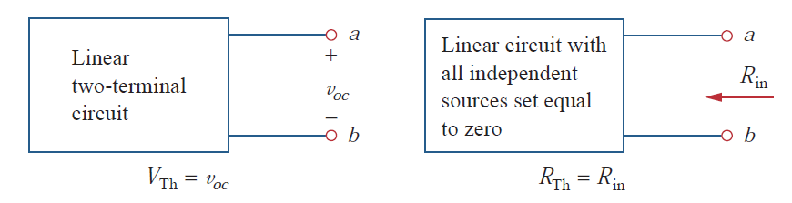

Circuit Diagram

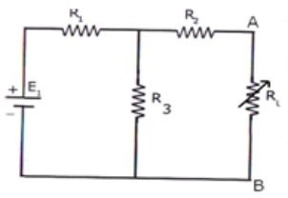
Fig.6.1: Measurement of V_{th} or V_{oc} .

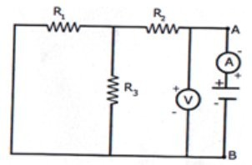
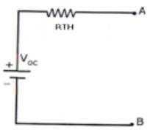
Fig. 6.3.: Measurement of I_{L} ( I_{L} = V_{Th} / ( R_{Th} + R_{L}) ).
Fig. 6.2.: Measurement of R_{Th}.

Required Equipment:

- Multimeter
- Resistors
- Bread Board
- Connecting Wires
- Power Supply

Procedure:
- Connect the circuit diagram as shown in fig.6.1
- Measure current in R_{L}.
- Connect the circuit as shown in fig. 6.2.
- Measure open circuit voltage Voc by open circuiting terminals i.e, V_{th}
- Draw the Thevenin’s equivalent circuit as shown in fig6.3
- Measure current flows through R_{L}

Precautions
- Follow the manufacturer’s instructions and lab manual for using the equipment. Directions in the user manual provide recommended operating procedures and safety precautions.
- Never hurry. Haste causes many accidents.
- Connect the power source last. Disconnect the power source first.
- Use safety goggles if necessary.
- Notify lab assistant immediately if any injuries or hazard is happened
- Before connecting the power, check your wiring carefully for agreement with the wiring diagram for an accidental short-circuit and for loose connections.

Data Table:

Parameters | Theoretical Values | Practical Values
Voc
Rth
I_{L}

Data analysis:
- Analyze the obtained data and plot the figures if needed.
- Compare the simulation results with your experimental data /wave shapes and comment on the difference (If any).

Results and Discussion:
- Interpret the data /findings and determine the extent to which the experiment was successful in complying with the goal that was initially set.
- Detect the variation between theory and experimental result if any and propose the ways
/procedures to overcome the variations.
- State the particular steps adopted to overcome the deviations between theory and experiment.

Conclusion:
Summarize the experiment and discuss whether the objectives were fulfilled or not with in a short paragraph.

Reference

- Robert L. Boylestad , “Introductory circuit analysis’’, prentice Hall , 12th Edition , Newyork, 2010, ISBN 9780137146666.
- Charles Alexander and Matthew Sadiku , “Fundamentals of Electric Circuits’’ 6th Edition ISBN 9780078028229 .

Pre-Lab Viva Questions:
  - What is load resistance?
  - How will you calculate Thevenin’s resistance?
  - How will you calculate Thevenin’s voltage?
  - How will you calculate load current I_{L}?

Post Lab Viva Questions:
- Write the applications of Thevenin’s theorem.
- Write the limitations of Thevenin’s theorem.

- Verification of Maximum Power Transfer Theorem.
Objective: To design the load resistor which absorbs maximum power from source.

Theory:
The maximum power transfer theorem states that maximum power is delivered from a source to an load resistance when the load resistance is equal to source resistance. (RL = Rs is the condition required for maximum power transfer).

Circuit Diagram:

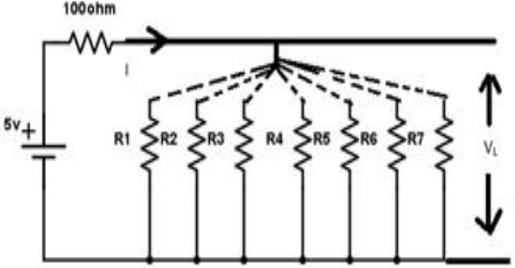

Fig. 6.2: Maximum Power Transfer Circuit

Required Equipment:

- Multimeter
- Resistors
- Bread Board
- Connecting Wires
- Power Supply

Procedure:
- Connect the circuit as shown in fig.6.2
- Vary the load resistance in steps and note down voltage across the load and current flowing through the circuit.
- Calculate power delivered to the load by using formula P=V*I.
- Draw the graph between resistance and power (resistance on X- axis and power on Y-axis).
- Verify the maximum power is delivered to the load when RL = Rs for DC.

Precautions
- Follow the manufacturer’s instructions and lab manual for using the equipment. Directions in the user manual provide recommended operating procedures and safety precautions.
- Never hurry. Haste causes many accidents.
- Connect the power source last. Disconnect the power source first.
- Use safety goggles if necessary.
- Notify lab assistant immediately if any injuries or hazard is happened
- Before connecting the power, check your wiring carefully for agreement with the wiring diagram for an accidental short-circuit and for loose connections.

Data Table:

S. No | R_{L} | V | I | P=VI
1
2
3
4
5
6
7

Graph:

Data analysis:
- Analyze the obtained data and plot the figures if needed.
- Compare the simulation results with your experimental data /wave shapes and comment on the difference (If any).

Results and Discussion:
- Interpret the data /findings and determine the extent to which the experiment was successful in complying with the goal that was initially set.
- Detect the variation between theory and experimental result if any and propose the ways
/procedures to overcome the variations.
- State the particular steps adopted to overcome the deviations between theory and experiment.

Conclusion:
Summarize the experiment and discuss whether the objective were fulfilled or not within a short paragraph.

Reference
- Robert L. Boylestad , “Introductory circuit analysis’’, prentice Hall , 12th Edition , Newyork, 2010, ISBN 9780137146666.
- Charles Alexander and Matthew Sadiku , “Fundamentals of Electric Circuits’’ 6th Edition ISBN 9780078028229 .

Pre-Lab Viva Questions:
- State maximum power transfer theorem.
- Is it possible to apply maximum power transfer theorem to ac as well as dc circuit?
- How to find power using maximum power transfer theorem?

Post Lab Viva Questions:

- What are conditions for maximum power transfer theorem?
- Is it possible to apply maximum power transfer theorem to nonlinear circuit?

